## Milestone 2: Project Checkpoint [15 pts] (Due: 5/1/18)

For this milestone, you must submit your well-commented code in its current state and a status report. Your code should run and functionality should be at or approaching your low-target goals.

Your report should contain (1) overview of your project, (2) progress to date, (3) images showing current results from your code, (4) any roadblocks or issues thus far, and (5) your plan for finishing the remaining items. Submit one zip file in Moodle.

**Project Overview (****disclaimer: I’m super behind):**

So after searching around the web I found a really great tutorial on a pre trained transfer model. I watched the video as I followed the online instructions provided (links below). I ran into some difficulties getting the file to work properly on the computer. I’m not sure how/what I need from the website in order to run it on my own machine. Most of the techniques used in this tutorial we have gone over in class before. This program uses the VGG-16 neural network model which does a pretty good job at making a style transfer image. Because the transfering takes a good amount of time, I’m not sure if I can alter the code to work with live video. I could potentially take a video, turn it into a gif and then run it through the program. Once I get the program actually running I’ll be able to look into it more and alter it.

<https://www.youtube.com/watch?v=LoePx3QC5Js>

<https://github.com/Hvass-Labs/TensorFlow-Tutorials/blob/master/15_Style_Transfer.ipynb>

**Progress to Date:**

Contrast Program (to be later implemented into the code)

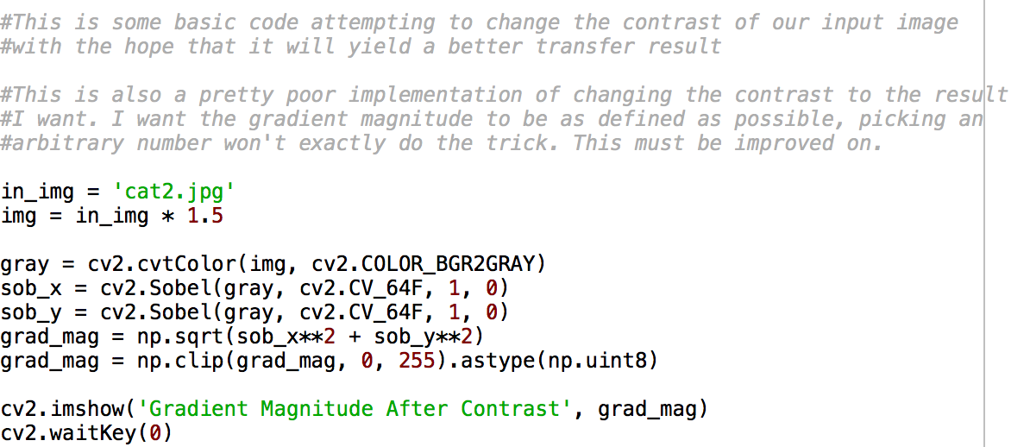

**Images Showing Current Results:**

I got nothing, next milestone definitely will though!

**Roadblocks/Issues:**

I have a pretty good grasp on how the Style Transfer program works however implementing it on my own remains a little too advanced for me. I definitely have to spend a little more time on his website to see if there are other examples on how to run his projects (he has a bunch about TensorFlow). Not being able to actually manipulate and run the program makes it a little difficult to make progress. I’ve been trying to understand Github Desktop to see if that will run it but I haven’t had much success with that either.

**Future Work:**

I want to finish my contrast file/add it to the original code. This method, in theory, would make the content images have stronger contours and features so that the final image has better quality. I want to run some tests with simple style images (one color, one texture) and see if adding contrast will better the results.

I also want to adjust some of the tuneable settings (iterations/step-size) to see how this affects quality as well.

Originally I intended on creating a gif that runs through different images. I will try my best to get this to work. I plan on outputting three separate styles on the same content image and creating a gif by going from one stylized image to the next by altering their opacities over time. I think this would be better than having to alter the very complex model.

So as of now my different target goals are as follows:

1. Low: Getting the program to run on my own device so I can use my own images/alter its settings. Running some tests to see how different style images affect content images
2. Medium: Get the gif component running on a still image
3. High: Be able to take a short video, convert it to a gif and have the style transfer onto it

Below are some images of mine that I’m going to manipulate once the program works.

